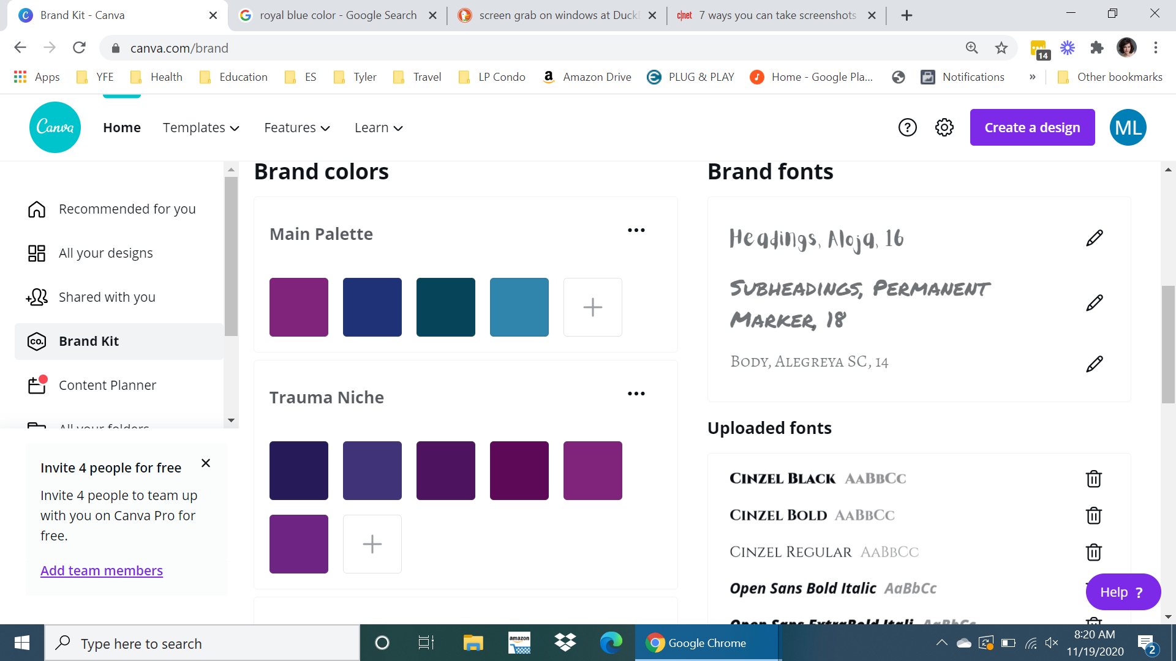
#80237B #1F3277 #064559 #3085AC

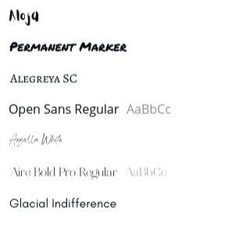
Fonts:
Aloja, Permanent Marker and Alegreya SC are to be used mostly for Social Media marketing purposes.

Angella White is a script font mainly used as headers, in the logo, and where a script font is desired. This font replaced Santorine

Aire Bold Pro Regular as a sub-heading font and used in instances where boldness with a soft edge is desired

Open Sans is a widely used web font. We use it on our
website and for body content. The full font family has 10 different weights, but we mainly
use a regular or light weight.

Glacial Indifference is mainly used for the body text in the new course workbooks.
The name of the font on the Mended Light Logo Is Aire Bold Pro Regular

